Trashtrekker: Smart Waste Management System

SUBMITTED IN PARTIAL FULFILLMENT FOR THE REQUIREMENT OF THE AWARD OF DEGREE OF

BACHELOR OF TECHNOLOGY
IN
COMPUTER SCIENCE



Submitted by

KARAN AGARWAL (2000290120082)

KARNIK GAUTAM (2000290120083)

HARSH YADAV (2000290120073)
.
Supervised by

DR. GAURAV DUBEY
PROFESSOR

Session 2023-24

DEPARTMENT OF COMPUTER SCIENCE
KIET GROUP OF INSTITUTIONS, GHAZIABAD
(Affiliated to Dr. A. P. J. Abdul Kalam Technical University, Lucknow, U.P., India)

MAY 2024
DECLARATION
We hereby declare that this submission is our own work and that, to the best of our knowledge and belief, it contains no material previously published or written by another person nor material which to a substantial extent has been accepted for the award of any other degree or diploma of the university or other institute of higher learning, except where due acknowledgment has been made in the text.

Name:- Karan Agarwal, Karnik Gautam, Harsh Yadav
Roll No.:- 2000290120082, 2000290120083, 2000290120073

CERTIFICATE

This is to certify that Project Report entitled “Trashtrekker: Smart Waste Management System” which is submitted by Karan Agarwal, Karnik Gautam, Harsh Yadav in partial fulfillment of the requirement for the award of degree B. Tech. in Department of Computer Science of Dr. A.P.J. Abdul Kalam Technical University, Lucknow is a record of the candidates own work carried out by them under my supervision. The matter embodied in this report is original and has not been submitted for the award of any other degree.
.

Dr. Gaurav Dubey
(Professor)

ACKNOWLEDGEMENT

It gives us a great sense of pleasure to present the report of the B. Tech Project undertaken during B. Tech. Final Year. We owe special debt of gratitude to Professor Gaurav Dubey, Department of Computer Science, KIET, Ghaziabad, for his constant support and guidance throughout the course of our work. His sincerity, thoroughness and perseverance have been a constant source of inspiration for us. It is only his cognizant efforts that our endeavors have seen light of the day.
We also take the opportunity to acknowledge the contribution of Dr. Ajay Kumar Srivastava, Head of the Department of Computer Science, KIET, Ghaziabad, for his full support and assistance during the development of the project. We also do not like to miss the opportunity to acknowledge the contribution of all the faculty members of the department for their kind assistance and cooperation during the development of our project.
Last but not the least, we acknowledge our friends for their contribution in the completion of the project.

Signature: Signature:
Name: Karan Agarwal Name: Karnik Gautam
Roll No.: 2000290120082 Roll No.: 2000290120083

Signature:
Name: Harsh Yadav
Roll No.: 2000290120073

ABSTRACT

Smart cities integrate multiple mobile or web solutions to build a comfortable human
habitation.
Multiple mobile or online technologies are combined in smart cities to create a comfortable
environment for people to live. Offering a waste management system that is efficient,
effective, and ecologically beneficial is one of these alternatives. The existing garbage
collection system involves routine garbage trucks making daily or weekly rounds, which is
not only a grossly wasteful use of public resources but also dosen’t reach every part of the
city. The suggested approach, in which the admin operates the web app for complete online-
based monitoring and system analysis. Bins, the driver, user complaints, and job updates
from the driver are managed by her admin. The government can use the resources at its
disposal to effectively manage the enormous volumes of rubbish that are picked up every
day, and this paper offers a cost-effective mobile or web-based solution that will do both of
these tasks. A more effective remedy for the inconvenience caused to the population by
garbage disposal. A driver handles this an app will offer recommended and supervised routes
for garbage trucks. Then after, the driver will change the status of the task that has now been
completed. For the workforce and residents, an android or web app that mainly provides the
user the ability to create complaints is provided in a smart bin.

TABLE OF CONTENTS | Page No.
DECLARATION……………………………………………………………………. | 2
CERTIFICATE……………………………………………………………………… | 3
ACKNOWLEDGEMENTS…………………………………………………………. | 4
ABSTRACT………………………………………………………………………..... | 5
LIST OF FIGURES…………………………………………………………………. | 8
LIST OF TABLES…………………………………………………………………… | 9
LIST OF ABBREVIATIONS………………………………………………………. | 10

CHAPTER 1 INTRODUCTION………………………………………………………...11-14
1.1 INTRODUCTION TO PROJECT…………………………………………………….11
1.2 PROJECT CATEGORY………………………………………………………………11
1.3 OBJECTIVES…………………………………………………………………………11
1.4 STRUCTURE OF THE REPORT…..…………………………….........................12-14

CHAPTER 2 LITERATURE REVIEW…………………………………………………15-20
2.1 LITERATURE REVIEW…………………………………………………………14-17
2.2 RESEARCH GAPS……………………………………………………………….18-19
2.3 PROBLEM FORMULATION……………………………………………………19-20

CHAPTER 3 PROPOSED SYSTEM……………………………………………………21-23
3.1 PROPOSED SYSTEM………………………………………………....................21-22
3.2 UNIQUE FEATURES OF THE SYSTEM………………………………………..22-23

CHAPTER 4. REQUIREMENT ANALYSIS AND SYSTEM SPECIFICATION……. 24-32
4.1 FEASIBILITY.……………………………………………………………………24-26
4.2 SOFTWARE REQUIREMENT SPECIFICATION DOCUMENT………….........26-27
4.2.1 DATA REQUIREMENT………………………………………………………….26
4.2.2 FUNCTIONAL REQUIREMENT…………………………………………….27
4.2.3 PERFORMANCE REQUIREMENT………………………………………….27
4.2.4 MAINTAINABILITY REQUIREMENT……………………………………...27
4.2.5 SECURITY REQUIREMENT………………………………………………...27
4.3 SDLC MODEL TO BE USED………………………………………………............28
4.4 SYSTEM DESIGN…………………………………………………......................28-30
4.2.1 DATA FLOW DIAGRAMS…………………………………………………28-29
4.2.2 USE CASE DIAGRAMS…………………………………………………….29-30
4.5 DATABASE DESIGN……………………………………………………………..30-32
4.5.1 ER DIAGRAMS………………………………………………......................30-32

CHAPTER 5. IMPLEMENTATION, TESTING, AND MAINTENANCE…………….33
5.1 INTRODUCTION TO LANGUAGES, TOOLS AND TECHNOLOGIES
USED FOR IMPLEMENTATION………………………………………………….33

CHAPTER 6. TESTING, AND MAINTENANCE…………………………………34-36
6.1 TESTING TECHNIQUES AND TEST CASES USED……………………....34-36

CHAPTER 7. RESULTS AND DISCUSSIONS……………………………………….. 37-42
7.1 DESCRIPTION OF MODULES WITH SNAPSHOTS…………………………..37-40
7.2 KEY FINDINGS OF THE PROJECT…………………………………………..41-42
7.3 BRIEF DESCRIPTION OF DATABASE WITH SNAPSHOTS………………..42

CHAPTER 8. CONCLUSION AND FUTURE SCOPE ……………….....................43

REFERENCES………………………………………………………………………44-48
RESEARCH PAPER ACCEPTANCE PROOF
RESEARCH PAPER (IF PRESENTED/ PUBLISHED)
PROOF OF PATENT PUBLICATION (SCREENSHOT OF PUBLICATION)……..49

LIST OF FIGURES

Figure No. | Description | Page No.
3.1  4.1 | Proposed System  0 Level DFD | 23  28
4.2 | 1 Level DFD | 29
4.3 | Use Case Diagram | 30
4.4  4.5  4.6  7.1  7.2  7.3  7.4  7.5 | ER Diagram  Detailed Design of the system  Architectural Diagram  Hardware Implementation  Dashboard  Table of Areas  Admin View  Database | 31  31  32  38  39  39  40  42

LIST OF TABLES

Table. No. | Description | Page No.
6.1 | Test Cases Used | 32-34

LIST OF ABBREVIATIONS

GUI Graphic User Interface
LED Light Emitting Diode
IOT Internet of Things

CHAPTER 1
INTRODUCTION

  - INTRODUCTION
Smart waste management is an innovative approach to handling and collecting waste . Based on IoT (Internet of Things) technology, smart waste management provides data on waste generation patterns and behavior. This empowers municipalities, cities, and waste collectors to optimize their waste operations, become more sustainable, and make more intelligent business decisions.
• An android or web app is developed for the work force and the citizens, which primarily provides the pop ups message to all municipality employee regarding in this location and our dustbin is completely full no more space in that you have to empty it.

  - PROJECT CATEGORY
Our project belongs to the industry automation category. This project involves the use of technology to optimize the collection, sorting, recycling, and disposal of waste materials.

  - OBJECTIVES
Garbage management system is a idea where we can control lots of problems which disturbs the society in pollution and diseases. The garbage management has to be done instantly else it leads to irregular management which will have adverse effect on nature.
The main objectives of our proposed system are as follows:
• Monitoring the garbage management. Providing a smart technology for garbage system.
• Providing a smart technology for garbage system.
• Reducing human time and effort .
• Resulting in healthy and waste ridden environment.

  - STRUCTURE OF THE REPORT
Preliminary Pages:
Declaration: Statement of authenticity by the author(s) regarding the work presented in the report.
Certificate: Confirmation of the completion of the project under specified supervision.
Acknowledgements: Recognition of individuals or organizations that contributed to the project.
Abstract: Brief summary highlighting the objectives, methodology, and key findings of the report.
List of Figures: Enumeration of all figures (diagrams, charts, etc.) included in the report.
List of Tables: Compilation of all tables included in the report for quick reference.
List of Abbreviations: Catalog of abbreviations used throughout the report with their definitions.
Chapter 1: Introduction:
Introduction to Project: Overview of the IoT-based smart waste management project.
Project Category: Classification of the project within the field of research or application.
Objectives: Clear statement of the project's goals and objectives.
Structure of the Report: Outline of how the report is organized and what each chapter covers.
Chapter 2: Literature Review:
Literature Review: Comprehensive analysis of existing literature related to IoT-based smart waste management.
Research Gaps: Identification of gaps in current research that the project aims to address.
Problem Formulation: Definition and articulation of the specific problem being tackled by the project.
Chapter 3: Proposed System:
Proposed System: Description of the designed IoT-based smart waste management system.
Unique Features of the System: Highlighting innovative aspects and functionalities of the proposed system.
Chapter 4: Requirement Analysis and System Specification:
Feasibility: Assessment of the feasibility (technical, economic, operational) of the proposed system.
Software Requirement Specification Document: Detailed specifications including data, functional, performance, maintainability, and security requirements.
SDLC Model to be Used: Selection and justification of the Software Development Life Cycle (SDLC) model.
System Design: Detailed design aspects including data flow diagrams, use case diagrams, and database design (ER diagrams).
Chapter 5: Implementation, Testing, and Maintenance:
Introduction to Languages, Tools, and Technologies Used: Overview of technologies employed for system implementation.
Testing Techniques and Test Cases Used: Description of methodologies and test cases used for system validation.
Chapter 6: Results and Discussions:
Description of Modules with Snapshots: Detailed breakdown of system modules with visual representations.
Key Findings of the Project: Presentation and analysis of project outcomes and findings.
Brief Description of Database with Snapshots: Overview of the project's database structure with visual aids.
Chapter 7: Conclusion and Future Scope:
Conclusion: Summary of project achievements, implications, and contributions.
Future Scope: Potential areas for further research, development, or enhancement of the proposed system.
References:
Comprehensive list of all sources referenced or cited throughout the report to acknowledge scholarly contributions.
Appendices:
Includes additional materials such as research paper acceptance proof, published research paper, or patent publication proof, if applicable.

CHAPTER 2
LITERATURE REVIEW

  - Literature Review
RESEARCH PAPER 1 - Internet of things (IoT) based Smart Garbage monitoring system.
In this research paper we have that because of the harmful consequences for the environment, garbage waste monitoring, collection, and management is one of the main issues of the modern day. The usual approach of manually examining and collecting trash is a tedious procedure that increases prices since it needs a large amount of time and human labour. In this work, an open IoT platform and an IoT-based waste monitoring system are proposed. An Arduino microcontroller, an ultrasonic sensor, a load cell, and a Wi-Fi module comprise up the system. Periodically throughout each day, live updates of the garbage bin status are provided via the social network website Twitter. A tweet reporting the status of a garbage can that is full or overcrowded allows authorized individuals to take the necessary action. Public awareness of management of waste and waste pollution may grow as a result of information sharing. With this system, the admin can properly plan and keep a record of garbage pickup. This technology would improve environmental hygiene, contribute to intelligent waste management, and help make cities cleaner.

RESEARCH PAPER 2 - An Internet of Things Based Smart Waste Management System Using LoRa and Tensorflow Deep Learning Model .
Waste management is an expensive endeavor as it necessitates a great deal of time and resources. The development of the recyclable bin and the launch of the 3Rs campaign are instances of measures the authorities have taken to boost waste management systems (recycle, reuse and reduce). The present waste management system has been enhanced thanks to advancements in IoT. Real-time monitoring, which was not feasible with the current waste management system, is made possible by the use of sensors in the trash can and IoT connectivity. The sensors may be used to collect data such as fill levels, temperature, humidity, and any other critical information. The storage and processing of these data can therefore be handled on the cloud. The data that have been examined could be used to research and uncover the flaws of the current waste management system. The recyclables container is further divided into various types of waste, including paper, metal, and plastic. As many as four specific types of bins have been positioned at a garbage collection location as a result of this practice. The overall operating expense for managing the bin inevitably goes up as a consequence of this.

RESEARCH PAPER 3- Smart Waste Management System using IoT.
The difficulties with sanitation and trash management are becoming progressively worse. It causes unhygienic conditions for the local populations, which accelerates the spread of infectious diseases and illnesses. IoT-based "Smart Waste Management" is the most effective and popular alternative to address this issue. The proposed system will equip public garbage cans with embedded equipment that allows for real-time monitoring of the level of garbage within the garbage cans. The integration of moisture sensors and load sensors will enhance the accuracy of data relevant to garbage level and waste segregation in a dust bin, correspondingly. The information on which dumpster should be placed in which location by their corresponding ids will be maintained in a database. The dustbin incorporates a humidity sensor to differentiate among wet and dry garbage, along with UV and load sensors for level determination. Employing analysis tools like Hadoop or Storm, the cloud-collected data will be analyzed to derive relevant facts on waste management. The proposed methodology guarantees that garbage will be collected as soon as it reaches its maximum level. As a consequence, the will produce accurate reports, improving system efficiency. The total number of trips that the GCV must make will be minimized due to the real-time monitoring of the garbage level made possible by sensors and wireless connectivity, which will also reduce the overall cost of garbage collection.

RESEARCH PAPER 4- A Proposed IoT Based Smart Waste Bin Management System with An Optimized Route: A Case Study of Ghana.
A technique is put forward that utilizes a number of adjustments to deal with spillage and unsuccessful collection techniques. By issuing orders for the garbage collectors that may be accessed via a mobile application system, the system gives the waste management institution a monitoring platform to handle the alert records. The proposed solution includes a smart trash can that is integrated with a microcontroller-based system that is integrated inside and attached to the top of the bins to detect bin level status and communicate with drivers and the management department via SMS and application system. The construction of a smart bin who used a microcontroller, a sensor for waste level detection, and an unit for network connectivity was displayed. A street cleaner should have access to the same information as just a garbage collector, be able to determine where full bins are located on a map, and be able to determine the most efficient routes for gathering bins. The framework for waste management that have been proposed in this work consists an improved routing and an alternate SMS alert to garbage collectors. The methodology presented in this article for tackling a waste management concern that is gaining a lot of attention globally constitutes a contribution to the body of knowledge.
RESEARCH PAPER 5 - RFID-based Real-time Smart Waste Management.
System Waste disposal and collection pose a serious threat to the environment, particularly in Australia's metropolitan areas today. Typically, waste collection vehicles collect trash from various residences and transport it to a landfill for disposal. Furthermore, landfills are much more expensive to run over time and have a tendency to fill up, demanding renovation. The waste collection vehicle's PDA houses a Based separation RFID scanner that transforms the radio waves reflected back from the trash can into digital information. The measuring process helps to identify each bin's weigh when it has been carried onto the vehicle by the trash collector's robotic arms. After emptying each bin, the information is used to determine the real costs of waste disposal for each household before being transferred to the PDA for short-term storage. In our waste management strategy, there is simply one route of interaction between waste tags, sensors, and back-ends. Our trash tags are cheap, inert, and have very little memory. For the creation of an RFID-based, sensor based, real-time automated WIWSBIS, we have created a multi-layer wastewater treatment architecture of the system.

  - RESEARCH GAPS
IoT-based smart waste management is a burgeoning field that leverages technology to optimize waste collection, monitoring, and disposal processes. Despite its potential, several research gaps and challenges remain. Here are some notable areas that warrant further investigation and development:
Optimal Sensor Deployment and Reliability:
Determining the optimal placement and density of sensors to accurately monitor waste levels in bins.Improving sensor reliability under various environmental conditions (e.g., extreme temperatures, humidity, and interference).
Data Security and Privacy:
Addressing concerns around data privacy and security when collecting, storing, and transmitting sensitive waste management data. Developing robust encryption and authentication mechanisms to protect IoT devices from cyber threats.
Data Analytics and Predictive Models:
Developing advanced analytics and machine learning models to predict waste generation patterns based on historical data, weather conditions, and seasonal variations. Implementing real-time predictive analytics for efficient waste collection scheduling and resource allocation.
Integration and Interoperability:
Establishing standards and protocols to facilitate seamless integration and interoperability among various IoT devices and waste management systems. Ensuring compatibility and scalability across different IoT platforms and technologies.
Energy Efficiency and Sustainability:
Exploring energy-efficient IoT solutions to prolong device battery life and reduce overall energy consumption. Investigating the environmental impact of IoT devices used in waste management systems.
Cost-Effectiveness and Scalability:
Conducting cost-benefit analyses to assess the economic viability of implementing IoT-based waste management systems. Evaluating scalability challenges associated with deploying IoT solutions across diverse urban environments and waste infrastructures.
Community Engagement and Behavior Change:
Studying the impact of IoT-based waste management systems on public awareness, behavior change, and community participation. Designing effective strategies to engage citizens and stakeholders in sustainable waste management practices.
Regulatory and Policy Frameworks:
Examining regulatory frameworks and policies governing the use of IoT technologies in waste management. Identifying legal and ethical considerations related to data ownership, liability, and accountability.
Environmental and Social Impact Assessment:
Assessing the broader environmental and social impacts of IoT-enabled waste management systems, including effects on air quality, landfill usage, and public health.
Human-Centric Design and Usability:
Conducting user-centered design studies to optimize the usability and accessibility of IoT interfaces for waste management personnel and stakeholders. Addressing usability challenges to ensure user acceptance and adoption of IoT solutions in waste management workflows.

  - PROBLEM FORMULATION

The waste management system is plagued by inefficiencies, including overflowing bins due to unpredictable usage patterns and lack of real-time monitoring, irregular collection schedules leading to unsanitary conditions, poor recycling rates stemming from citizen confusion on waste segregation, manual maintenance processes prone to errors, and increased environmental impact with unnecessary vehicle trips contributing to carbon emission. These issues demand urgent attention, highlighting the need for a Smart Waste Management System that optimizes collection routes, prevents overflow with real-time monitoring, promotes recycling through citizen education, automates maintenance tasks with IoT sensors, and ultimately aims to reduce the environmental footprint of waste management practices.

CHAPTER 3
PROPOSED SYSTEM

  - PROPOSED SYSTEM

Certainly, here's an expanded version of the proposed methodology for the smart waste management system:
Administrator:
1. Login: The admin will access the system through a secure login page, which serves as the gateway to the system's functionalities. This login requires the admin's username and password.
2. Create Garbage Bins: The administrator has the authority to create and register new garbage bins for various areas within the jurisdiction. These bins will be strategically placed to facilitate efficient waste collection.
3. Update/Delete Garbage Bins: The admin can update information about existing garbage bins, such as their location, capacity, and condition. Additionally, the admin can remove or delete bins that are no longer in use or are damaged beyond repair.
4. Assign Best Routes for Drivers: Based on data analysis and optimization algorithms, the administrator assigns optimal waste collection routes to drivers. This ensures that drivers cover the areas efficiently, minimizing travel time and fuel consumption.
5. Manage Drivers: The admin maintains a record of all drivers responsible for waste collection. This includes their contact information, work schedules, and performance evaluations. The admin can also allocate the best routes to drivers.
6. View Garbage Reports: The admin has access to comprehensive reports on waste generation and collection from all areas. These reports include data on fill levels, collection frequency, and any issues or discrepancies. This data is crucial for monitoring and decision-making.

General Public:
1. Register: Members of the public who wish to use the smart waste management service must register by providing their basic information. Registration is a one-time process to gain access to the application's services.
3. Register Complaints: Public users can submit complaints related to waste management issues. For example, they can report overflowing bins, unscheduled collections, or other problems they encounter in their locality.
4. View My Complaints & Status: Users can track the status of their submitted complaints through the application. They can check whether their reported issues have been resolved or are still pending.
Drivers:
1. Login: Drivers access the system through a dedicated login page. They must provide their unique credentials, including a username and password, to access the system.
2. Check Daily Work Updates: Drivers receive daily work updates through the system. These updates include their assigned routes, areas for collection, and any changes in their schedules.
3. Choose Best Routes: Drivers have the flexibility to choose the most efficient routes for waste collection within their assigned areas. They can use the application's routing recommendations to minimize travel time.
4. Update Garbage Load: After each collection, drivers update the system with information about the garbage load they have collected. This data includes details about the quantity and type of waste collected from each bin.

  - UNIQUE FEATURES OF THE SYSTEM
1. Real-Time Monitoring:
• Bin Fill-Level Sensors: Sensors installed in waste bins detect and transmit real-time data on the fill levels.
• Continuous Updates: Collection teams receive immediate notifications when bins are nearing full capacity, enabling timely pickups
2. IoT Integration:
Sensor Networks: IoT sensors in bins, trucks, and processing facilities for comprehensive data collection.
Centralized Control: Manage and monitor the entire waste management system from a centralized platform.

3. Dynamic Route Optimization:
AI-Powered Algorithms: Utilize algorithms to dynamically plan collection routes based on real-time data.
Efficient Scheduling: Minimize vehicle trips and fuel consumption by optimizing the most efficient collection paths.

4.Cloud-Based Data Storage and Management:
Secure Data Storage: Store and manage large volumes of waste management data in cloud-based platforms.
Remote Access: Access data and system controls from anywhere for efficient management and decision-making.
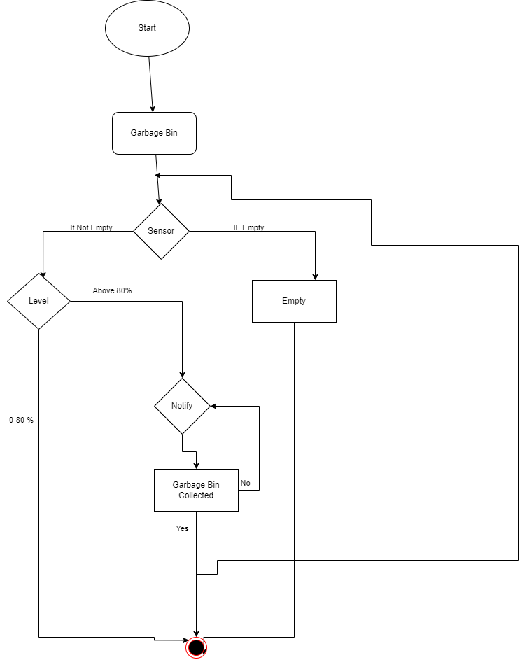
FIG 3.1 PROPOSED SYSTE
CHAPTER 04
REQUIREMENT ANALYSIS AND SYSTEM SPECIFICATION

4.1 FEASIBILITY STUDY

Conducting a feasibility study for an automated retail checkout system using YOLOv5 involves evaluating its technical, economic, and operational aspects. Following are the various components:

4.1.1 TECHNICAL FEASIBILITY:

4.1.1.1. System Design and Architecture
Component Description: Detailed description of system components such as sensors, IoT devices, data analytics software, mobile applications, and backend systems.
Integration Plan: How these components will interact and communicate with each other.
Scalability: Ability of the system to handle increased data volume and user load as the project expands.

4.1.1.2. Data Collection and Management
Sensor Technology: Assessment of sensor types (fill-level sensors, temperature sensors, RFID tags) and their suitability for the waste management needs.
Data Transmission: Evaluation of communication protocols (e.g., LoRaWAN, NB-IoT) for transmitting data from sensors to the central system.
Data Storage: Determining the storage requirements and selecting appropriate databases or cloud storage solutions.
Data Security: Implementation of encryption, access controls, and other security measures to protect sensitive waste management data.

4.1.1.3 Mobile and Web Applications
User Interface Design: Designing intuitive and user-friendly interfaces for citizens, waste management teams, and administrators.
Functionality: Features such as real-time bin monitoring, route optimization, recycling guides, and reporting tools.

4.1.2 ECONOMIC FEASIBILITY:

4.1.2.1 Initial Investment
Hardware Costs: Estimate the costs of sensors, IoT devices, RFID tags, bins, collection vehicles, and other necessary equipment.
Software Costs: Include expenses for developing or purchasing waste management software, mobile applications, and data analytics tools.
Installation and Setup Costs: Budget for installation, configuration, and integration of the system components.
.

4.1.2.2. Operational Costs
Maintenance and Support: Estimate ongoing costs for system maintenance, software updates, hardware repairs, and technical support.
Energy Consumption: Calculate the electricity or power required to operate sensors, IoT devices, and other system components.
Data Storage Costs: Include expenses for storing and managing waste management data in databases or cloud platforms.

4.1.2.3. Return on Investment (ROI)
ROI Calculation: Determine the projected ROI based on the total expected benefits divided by the total costs.
Payback Period: Estimate the time it will take for the project to pay for itself through cost savings and revenue generation.
Net Present Value (NPV): Assess the present value of future cash flows to determine the project's profitability.

4.1.3 OPERATIONAL FEASIBILTY

4.1.3.1 Understanding Current Operations
Process Mapping: Documenting the current waste collection, sorting, recycling, and disposal processes.
Identifying Pain Points: Gathering feedback from waste management personnel, administrators, and stakeholders on current challenges and inefficiencies.
4.1.3.2 User Acceptance
Stakeholder Engagement: Involving waste management teams, administrators, and citizens in the design and planning process.
User Interface Design: Ensuring the system's interfaces are intuitive, user-friendly, and aligned with the needs of different user groups.
4.2 SOFTWARE REQUIREMENT SPECIFICATION DOCUMENT

4.2.1 DATA REQUIREMENT

Bin Fill Level Data:
Continuous monitoring of fill levels using sensors installed in waste bins.
Timestamped data to track changes in fill levels over time.
Location Data:
GPS coordinates of waste bins, collection vehicles, and sorting facilities.
Geospatial data for mapping optimized collection routes and visualizing waste distribution.
Sensor Data:
Temperature, humidity, or other environmental sensor readings for waste storage areas.
RFID tag data for identifying and tracking waste items through the sorting process.

4.2.2 FUNCTIONAL REQUIREMENT

Real-Time Monitoring:
The system should be able to monitor the fill levels of waste bins in real time using sensors.It should provide alerts to waste management teams when bins reach predefined thresholds for collection.
Route Optimization:
Ability to calculate optimized waste collection routes based on real-time bin fill levels.
Integration with GPS systems to guide collection vehicles along the optimized routes.
4.2.3 PERFORMANCE REQUIREMENT

Data Processing and Analysis Performance
The system should:
Process large volumes of sensor data efficiently to generate actionable insights.
Analyze historical data to identify trends in waste generation and collection.
Generate reports and visualizations in a timely manner for waste management personnel and administrators.
4.2.4 MAINTAINABILITY REQUIREMENT

4.2.4.1 Code Maintainability

All the documents such as SRS, Test Plan, and Project Report is maintained. The code is maintained on github.

4.2.4.2 Updates and Upgrades
The updates and upgrades should be done on the basis of reducing the downtime of the system as a whole.

4.2.5 SECURITY REQUIREMENT

4.2.5.1 Access Control

The access of the system should be controlled by the administrator and only they can decide which employee the access should be given.

4.3 SDLC MODEL USED

The test methodology selected for the project is Agile. An Agile methodology is the most suitable for this project. By embracing Agile principles and practices, teams can create innovative and user-centric waste management solutions that optimize operations, enhance sustainability, and improve the quality of life in communities.. It is sequential development process that flows like a waterfall through all phases of a project (analysis, design, development, and testing, for example), with each phase completely wrapping up before the next phase begins.

4.4 SYSTEM DESIGN

4.4.1 DATA FLOW DIAGRAMS

4.4.1.1 DFD Level 0
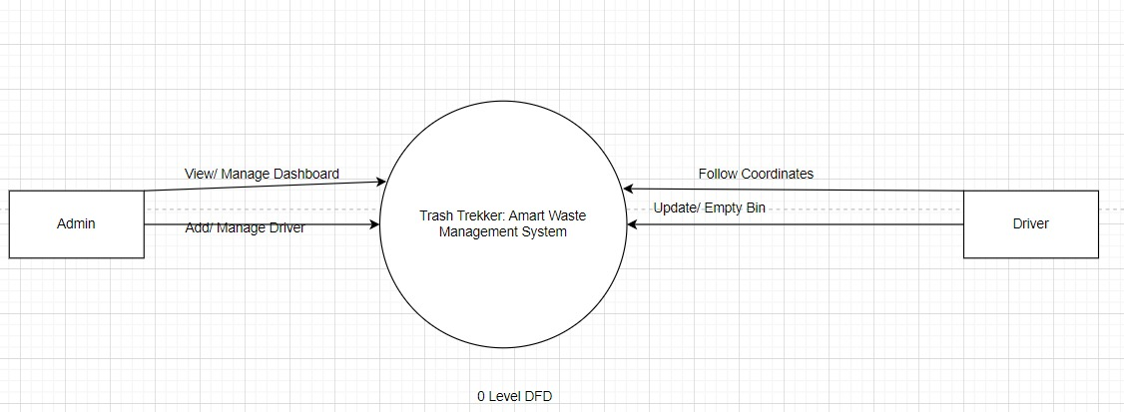

Fig. 4. 1 Level DFD

4.4.1.2 DFD Level 1
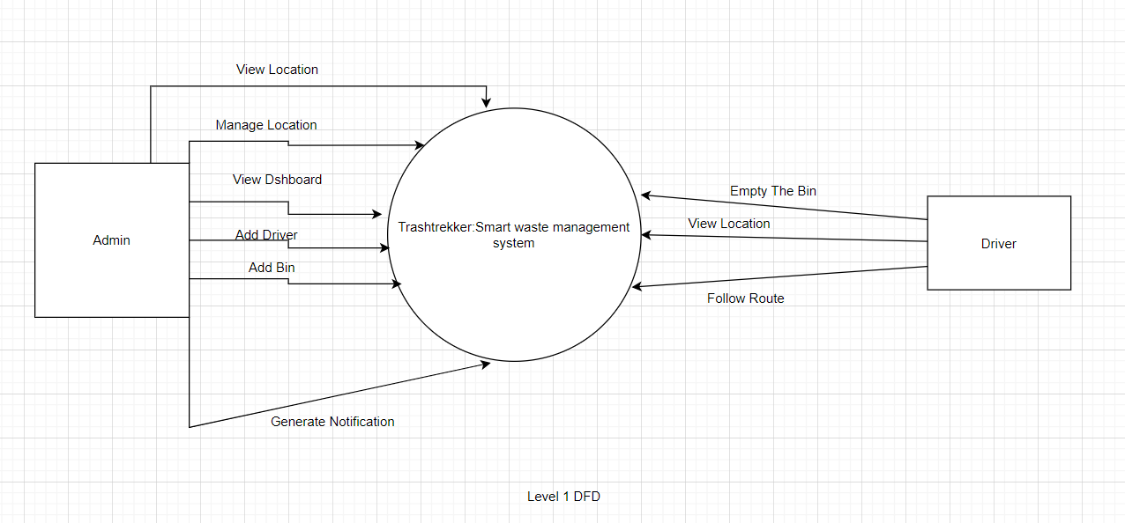
FIG 4.2 1 LEVEL DFD

4.4.2 USE CASE DIAGRAM
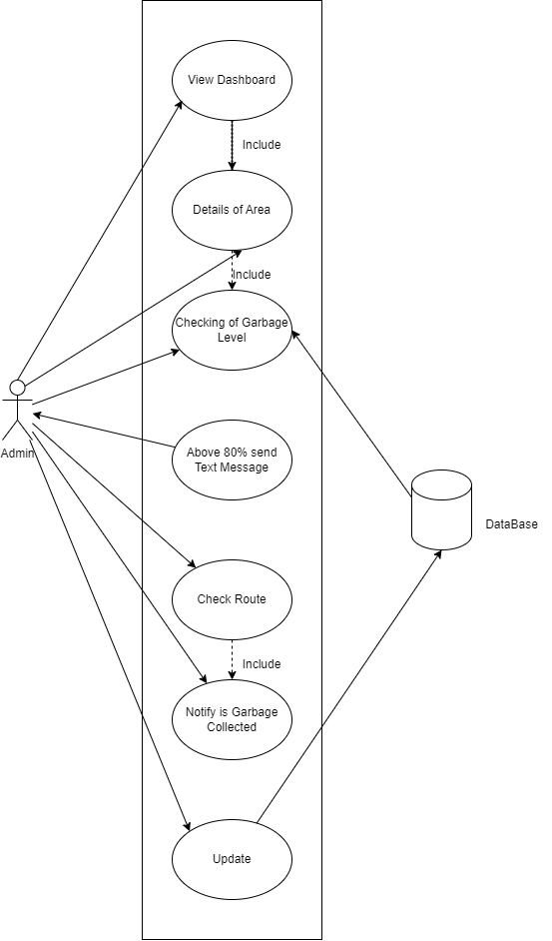

Fig. 4.3 Use Case Diagram
4.5 DATABASE DESIGN

4.5.1 E-R DIAGRAM
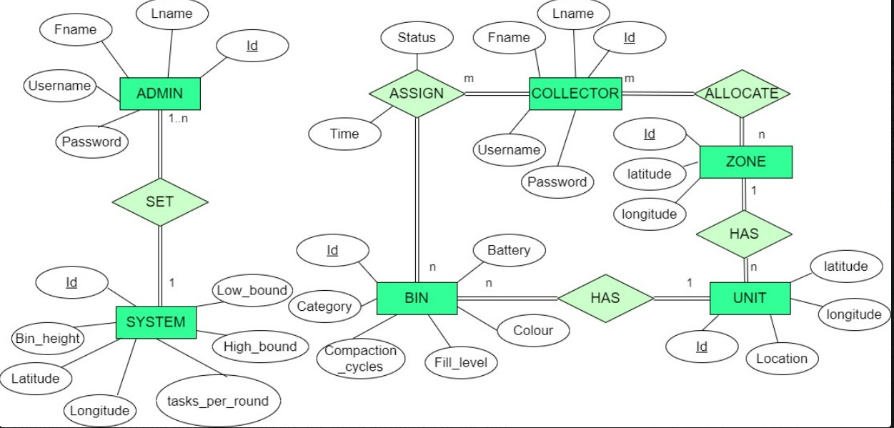
FIG 4.4 ER Diagram

4.6 DETAIL DESIGN

. Detailed Design of the System
FIG 4.5

4.7 Architectural design

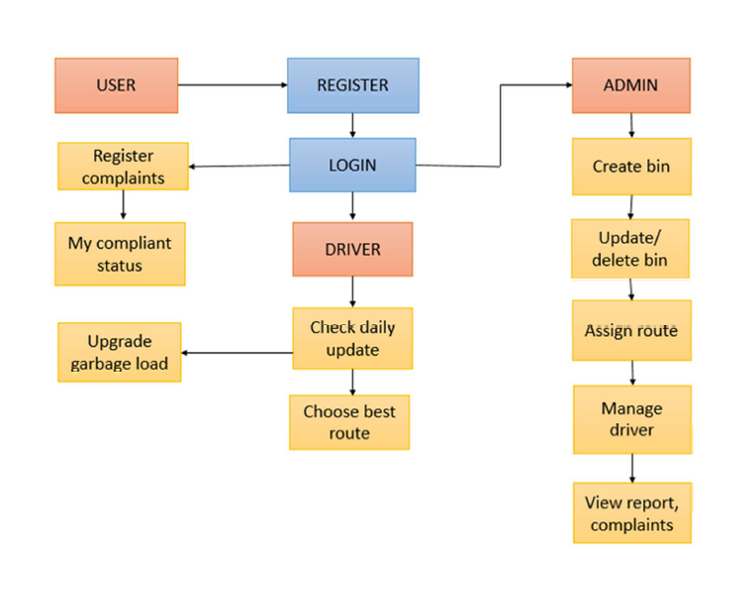
FIG 4.6 Architectural Design

CHAPTER 05

IMPLEMENTATION

5.1 INTRODUCTION TO LANGUAGES, TOOLS AND TECHNOLOGIES USED FOR IMPLEMENTATION

5.1.1 Language used:
Python ,Javascript , PHP, MY SQL

5.1.2 Toolkit:

SQLUnit: A tool for database testing that allows you to define and run SQL-based tests on your database.

Selenium: A popular tool for automated functional testing of web applications, which can be useful for testing user interfaces in your system.

Jenkins: An open-source automation server that can be used for building, testing, and deploying code continuously.

XAMPP: is a free and open-source cross-platform web server solution stack package developed by Apache Friends. The name "XAMPP" stands for:

X: Cross-platform (available for Windows, Linux, macOS, and more)
A: Apache HTTP Server
M: MySQL (or MariaDB, which is a drop-in replacement for MySQL)
P: PHP
P: Perl
XAMPP is designed to facilitate easy installation and setup of a local web development environment

.

5.1..3 Coding Environment:
Visual Studio Code

CHAPTER 06
TESTING AND MAINTENANCE
6.1 TESTING TECHNIQUES AND TEST CASES USED
The testing performed is white box testing.

6.1.1 TEST LEVELS
1. Unit Testing:
What: Testing individual units or components of the system in isolation.
How: Developers write tests for each function, method, or class.
Tools: Unit testing frameworks such as JUnit, NUnit, pytest.

2. Integration Testing:
What: Testing interactions between integrated units/modules.
How: Ensuring that units work together as expected.
Tools: Integration testing frameworks like TestNG, JUnit, Postman.

3. System Testing:
What: Testing the entire system as a whole.
How: Verifying all components work together in the intended environment.
Tools: Automated testing tools, custom scripts.

4. Acceptance Testing:
What: Ensuring the system meets user requirements and specifications.
How: Typically involves end-users or stakeholders.
Tools: User acceptance testing (UAT) frameworks, Selenium, Cucumber.

6.1.2 TEST CASES USED:

Table No. 6.1 – Test cases used

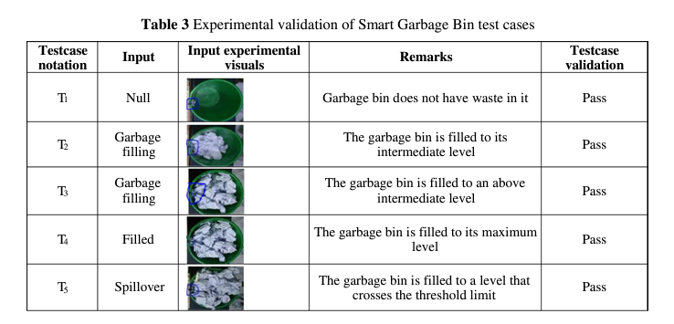

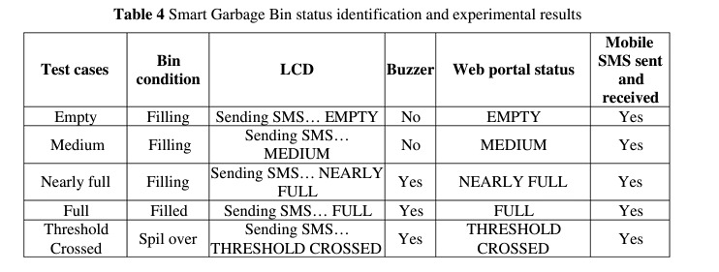
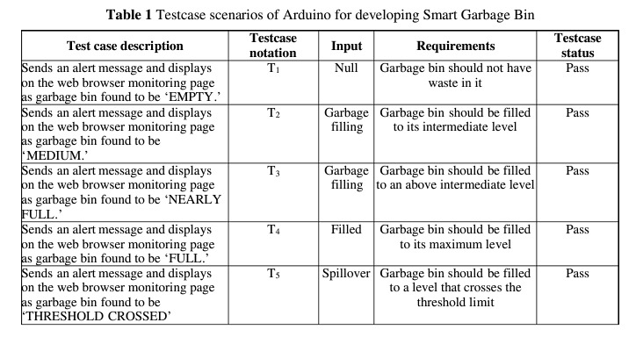

CHAPTER 07
RESULTS AND DISCUSSIONS

7.1 BRIEF DESCRIPTION OF VARIOUS MODULES OF THE SYSTEM WITH SNAPSHOTS

1. Node MCU

Node MCU is an open source IOT platform. It includes firmware which runs on the ESP8266WiFi SoC from Espressif Systems, and hardware which is based on the ESP12 module. Node MCU provides a way to connect different sensors to their controllers wirelessly via Wi-Fi. Since, it is an improved version of the ESP8266 it has better and easier programming, with better voltage stability and more reliability.

2. Ultrasonic Sensor

An optical sensor has a transmitter and receiver, whereas an ultrasonic sensor uses a single ultrasonic element for both emission and reception. In a reflective model ultrasonic sensor, a single oscillator emits and receives ultrasonic waves alternately. HC-SR04 is an ultrasonic sensor which is used for measuring the distance.

3. Arduino IDE

The open-source Arduino Software (IDE) makes it easy to write code and upload it to the board. It runs on Windows, Mac OS X, and Linux. The environment is written in Java and based on Processing and other open-source software. The Arduino IDE supports the languages C and C++ using special rules of code structuring. The Arduino IDE supplies a software library from the Wiring project, which provides many common input and output procedures. User-written code only requires two basic functions, for starting the sketch and the main program loop, that are compiled and linked with a program stub main() into an executable cyclic executive program with the GNU tool chain, also included with the IDE distribution. The Arduino IDE employs the program avrdude to convert the executable code into a text file in hexadecimal encoding that is loaded into the Arduino board by a loader program in the board's firmware.

SNAPSHOTS OF SYSTEM WITH BRIEF DETAIL OF EACH

Hardware Implementation
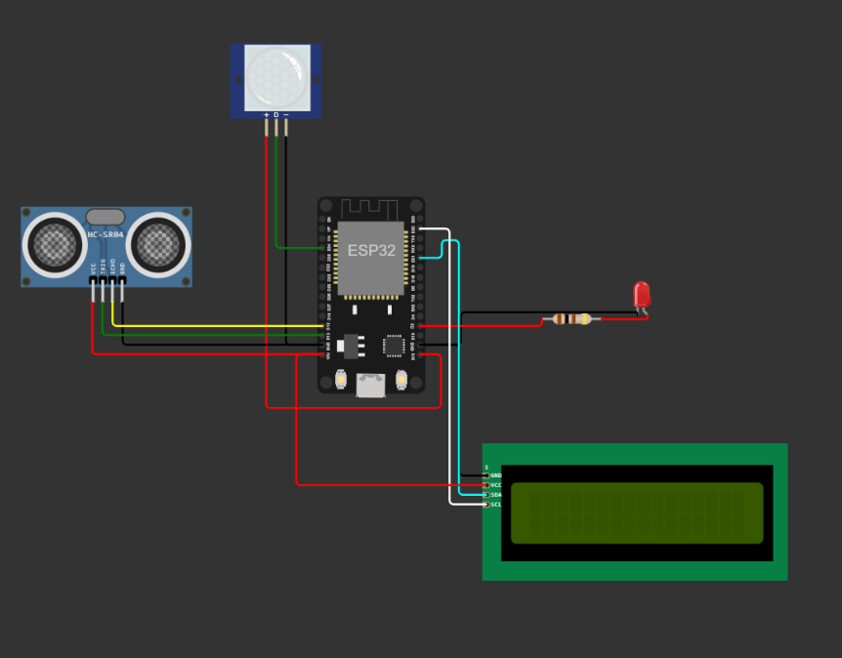
FIG 7.1 Hardware Implementation

This modules contain ultrasonic sensor ,esp32 microcontroller , 16x2 LCD module e.t.c.Ultrasonic sensor helps us to detect the presence of object near the dustbin. ESP32 is a wifi module that helps us to transfer the sensor data to the web app.

Dashboard
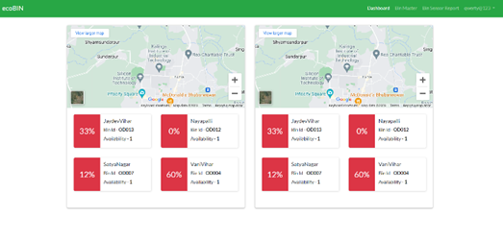

Fig. 7.2 Dashboard

A dashboard for a smart waste management system can provide real-time insights, analytics, and control over various aspects of waste collection, recycling, and disposal processes.

Table of Areas
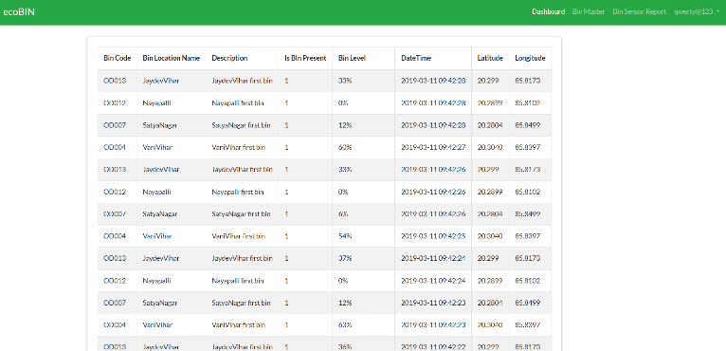
FIG 7.3

Each dustbin has its own dustbin ID and location where the bin is located. This dustbin ID and location are in a table and it shows the percentage of each dustbin in the table

USER INTERFACE REPRESENTATION
Admin View

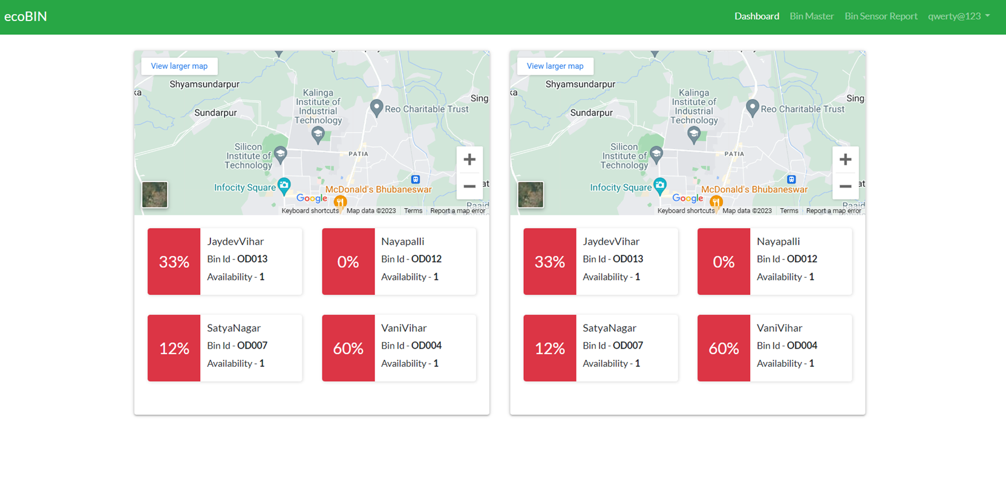
FIG 7.4 Admin View
7.2 Key Findings of the Project
Optimized Waste Collection:
Reduced collection costs and improved efficiency due to real-time monitoring of waste levels in bins. Optimized routing and scheduling of waste collection vehicles based on fill levels and demand patterns.
Reduced Environmental Impact:
Decreased carbon footprint through optimized collection routes, leading to reduced fuel consumption and emissions. Enhanced recycling and waste segregation practices due to improved data insights.
Enhanced Public Health and Sanitation:
Reduced overflow and littering incidents by ensuring timely waste collection based on fill levels. Improved cleanliness and hygiene in public spaces due to efficient waste management practices.
Data-Driven Decision Making:
Valuable insights gained from data analytics enable better decision making for waste management strategies. Predictive models based on historical data help anticipate waste generation patterns and optimize resource allocation.
Improved Citizen Engagement:
Increased awareness and participation among citizens in sustainable waste management practices. Enhanced public satisfaction with cleaner and more efficient waste disposal services.
Cost Savings and Resource Efficiency:
Cost-effective resource allocation based on real-time data, reducing unnecessary collections and associated expenses. Enhanced resource efficiency through better utilization of waste collection assets.
Scalability and Adaptability:
Identification of scalable solutions and technologies that can be adapted to different urban environments and waste infrastructures. Insights into the scalability challenges and opportunities for wider adoption of IoT-based waste management systems.

Operational Insights and Performance Metrics:
Monitoring system performance metrics such as uptime, data accuracy, and responsiveness to optimize operational efficiency. Identifying areas for continuous improvement and system optimization based on operational insights.

Regulatory and Policy Implications:
Understanding the impact of IoT-based waste management systems on existing regulations and policies. Proposing policy recommendations for integrating innovative waste management technologies into existing frameworks.

7.3 Brief Description of database with snapshots
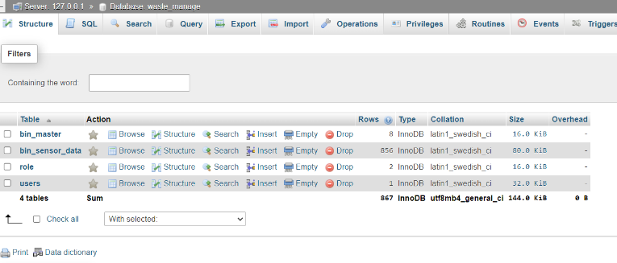

Fig. 7.5 Database

In this database it contain id, filled and percent where ID is auto-incremented and the filled and percent values are stored in the column name.

CHAPTER 08
CONCLUSION AND FUTURE SCOPE
We Design and completed the investigation of complex problem for our problem statement “IOT Based Smart Garbage and Waste Collection Bin”. We have applied Engineering Knowledge for investigation and analyze societal problem so that it will be beneficial for engineer and society. We have studied previous work which is related to our project, we have analyze these work and try to overcome the problems and drawbacks of their work. We make use of modern tools and technologies for faster and advance development of the system. During the development of our project we learned so many things that give us lifelong learning. We came to importance of each individual and the whole team also. Team management and coordination is the key point for the successful development of the project.

Future Scope

We have successfully completed the project “Smart Garbage Management”, but, there still room for change.

- Automatic Garbage Fill system helps us to reduce the pollution. Many times garbage dustbin is overflow and many animals like dog or cow enters inside or near the dustbin. Also some birds are also trying to take out garbage from dustbin. This project can avoid such situations.

- And the message can be sent directly to the cleaning vehicle instead of the contractor’s office. Apart from this, differentiation can be made between dry trash bin and wet trash bin collecting plastic dry waste and biodegradable waste respectively.

To implement this methane and smell sensors can be used. This helps in distinguishing the waste at the source and hence reducing the requirement of manpower. To enhance it further, an automated system can be developed which is able to pick up waste in and around the bin, segregate them and put them in respective bins.
REFERENCES

- Dr. K. Alice Mary, Perreddy Monica, A. Apsurrunisa , Chathala Sreekanth, G. Pavan Kumar “International Journal of Scientific & Engineering Research”, Volume 8, Issue 4, April-2017, ISSN 2229-5518.

- BitanBhattacharya, Hariharan Venkitakrishnan, Vinit Kr. Singh “SMART WASTE MONITORING”.

- Ms. Rupa, Ms. Rajni Kumari, Ms. Nisha Bhagchandani, Mr. Ashish Mathur “IOSR Journal of Engineering” Volume 08, Issue 5, May 2018, ISSN (e): 2250-3021.

- Ashima Bajaj, Sumanth Reddy “International Journal of Pure and Applied Mathematics” Volume 114, 12 2017, ISSN:
1311-8080.

- Gaurav Makde, Ashutosh Bele, Vaibhav Khapekar, Nidhi Gajarlwar, Sakshi Gajbhiye, Madhuri Dubey “Review on IOT Based Smart Garbage and Waste Collection System”, Volume: 05 Issue: 09 | Sep 2018, p-ISSN: 2395-0072

[6] L. Atzori, A. Iera and G. Morabito, "The Internet of Things: A survey", Comput. Netw., vol. 54, pp. 2787-2805, Oct. 2010.

[7] A. Meijer and M. P. R. Bolívar, "Governing the smart city: A review of the literature on smart urban governance", Int. Rev. Adm. Sci., vol. 82, no. 2, pp. 392-408, 2016.

[8] A. Zanella, N. Bui, A. Castellani, L. Vangelista and M. Zorzi, "Internet of Things for smart cities", IEEE Internet Things J., vol. 1, no. 1, pp. 22-32, Feb. 2014.
[9] A. S. Sadeq, R. Hassan, S. S. Al-rawi, A. M. Jubair and A. H. M. Aman, "A qos approach for Internet of Things (Iot) environment using mqtt protocol", Proc. Int. Conf. Cyber Security., pp. 59-63, Sep. 2019.

[10] A. Prasanna, S. K. Vikash and P. Mahalakshmi, "Survey on identification and classification of waste for efficient disposal and recycling", Int. J. Eng. Technol., vol. 7, no. 2.8, pp. 520-523, 2018.

[11] S. Mdukaza, B. Isong, N. Dladlu and A. M. Abu-Mahfouz, "Analysis of IoT-enabled solutions in smart waste management", Proc. 44th Annu. Conf. IEEE Ind. Electron. Soc., pp. 4639-4644, Oct. 2018.

[12] T. Saminathan, A. Musipatla, P. M. Varma, P. S. Khan and G. M. Kumar, "Iot based automated waste segregator for efficient recycling", Int. J. Innov. Technol. Exploring Eng., vol. 8, no. 6, pp. 164-166, 2019.

[13] D. Ziouzios and M. Dasygenis, "A smart recycling bin for waste classification", Proc. Panhellenic Conf. Electron. Telecommun. (PACET), pp. 1-4, Nov. 2019.

[14] H. Poddar, R. Paul, S. Mukherjee and B. Bhattacharyya, "Design of smart bin for smarter cities", 2017 Innov. Power Adv. Comput. Technol. i-PACT 2017, pp. 1-6, 2017-January, 2018.

[15] S. Aleyadeh and A. E. M. Taha, "An IoT-Based architecture for waste management", 2018 IEEE Int. Conf. Commun. Work. ICC Work. 2018 - Proc., pp. 1-4, 2018.

[16] J. Xia, G. Cheng, D. Guo and X. Zhou, "A QoE-aware service-enhancement strategy for edge artificial intelligence applications", IEEE Internet Things J., vol. 7, no. 10, pp. 9494-9506, Oct. 2020.

[17] S. Deng, H. Zhao, W. Fang, J. Yin, S. Dustdar and A. Y. Zomaya, "Edge intelligence: The confluence of edge computing and artificial intelligence", IEEE Internet Things J., vol. 7, no. 8, pp. 7457-7469, Aug. 2020.

[18] M. Ghahramani, N. J. Galle, F. Duarte, C. Ratti and F. Pilla, "Leveraging artificial intelligence to analyze citizens’ opinions on urban green space", City Environ. Interact., vol. 10, Apr. 2021.

[19] X. Jin, H. Qin, Z. Zhang, M. Zhou and J. Wang, "Planning of garbage collection service: An arc-routing problem with time-dependent penalty cost", IEEE Trans. Intell. Transp. Syst., vol. 22, no. 5, pp. 2692-2705, May 2021.

[20] D. Lei, M. Li and L. Wang, "A two-phase meta-heuristic for multiobjective flexible job shop scheduling problem with total energy consumption threshold", IEEE Trans. Cybern., vol. 49, no. 3, pp. 1097-1109, Mar. 2019.

[21] E. B. Tirkolaee, P. Abbasian, M. Soltani and S. A. Ghaffarian, "Developing an applied algorithm for multi-trip vehicle routing problem with time windows in urban waste collection: A case study", Waste Manage. Res., vol. 37, no. S1, pp. 4-13, 2019.

[22] E. B. Tirkolaee, M. Alinaghian, M. B. Sasi and M. M. S. Esfahani, "Solving a robust capacitated arc routing problem using a hybrid simulated annealing algorithm: A waste collection application", J. Ind. Eng. Manage. Stud., vol. 3, no. 1, pp. 61-76, 2016.

[23] L. Amal, L. H. Son and H. Chabchoub, "SGA: Spatial GIS-based genetic algorithm for route optimization of municipal solid waste collection", Environ. Sci. Pollut. Res., vol. 25, pp. 27569-27582, Jul. 2018.

[24] S Khan, S Venkat and K Jayavel, "IEEE International Conference on Power Control Signals and Instrumentation Engineering (ICPCSI) on" in Autonomous smart waste collection system using internet of things, IEEE, pp. 1181-1186, Sep 2017.

[25] Yu Zhang, Jianhao Jiao, Haoyu Huang et al., "Autonomous Robotic Waste Collection in Urban Environment: Bin- To-Bin", 2020 IEEE/RSJ International Conference on Intelligent Robots and Systems (IROS).

[26] M. Akhtar, M. A. Hannan, R. A. Begum, H. Basri and E. Scavino, "Backtracking search algorithm in CVRP models for efficient solid waste collection and route optimization", Waste Management, vol. 61, pp. 117-128, 2017.
[27] A. A. J. Jim, R. Kadir, M. A. A. Mamun, A.-A. Nahid and M. Y. Ali, "A noble proposal for Internet of garbage bins (IoGB)", Smart Cities, vol. 2, no. 2, pp. 214-229, 2019.

[28] M. Cerchecci, F. Luti, A. Mecocci, S. Parrino, G. Peruzzi and A. Pozzebon, "A low power IoT sensor node architecture for waste management within smart cities context", Sensors, vol. 18, no. 4, pp. 1282, 2018.

[29] Shanshan Meng and Wei-Ta. Chu, "A Study of Garbage Classification with Convolutional Neural Networks", 2020 Indo – Taiwan 2nd International Conference on Computing Analytics and Networks (Indo-Taiwan ICAN), pp. 152-157, 2020.

[30] D Bhavana, Raja Rajeswari, P Pasyanthi and K Yaswanth sai, "Garbage Segregation System with SMART Technology", (ICCCI), Jan. 25 – 27, 2022.

PROOF OF PATENT PUBLICATION

